**Assessment Analysis**

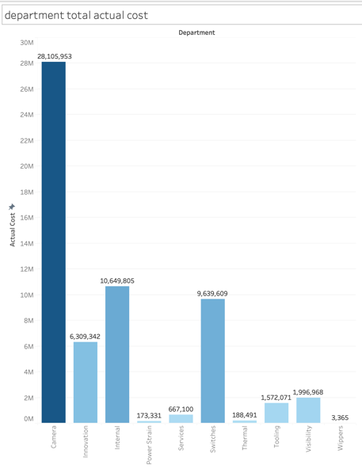

The departments total cost is leaded by the camera product.

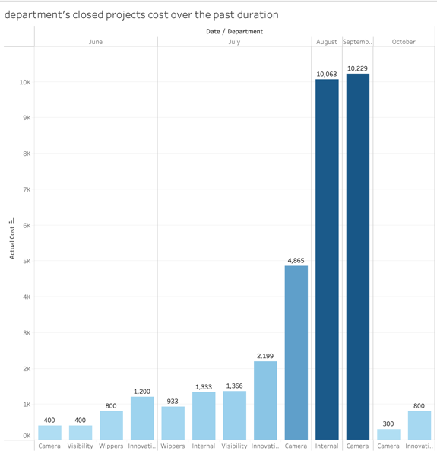

The project camera has a high cost by October.

The project internal has a high cost by September.

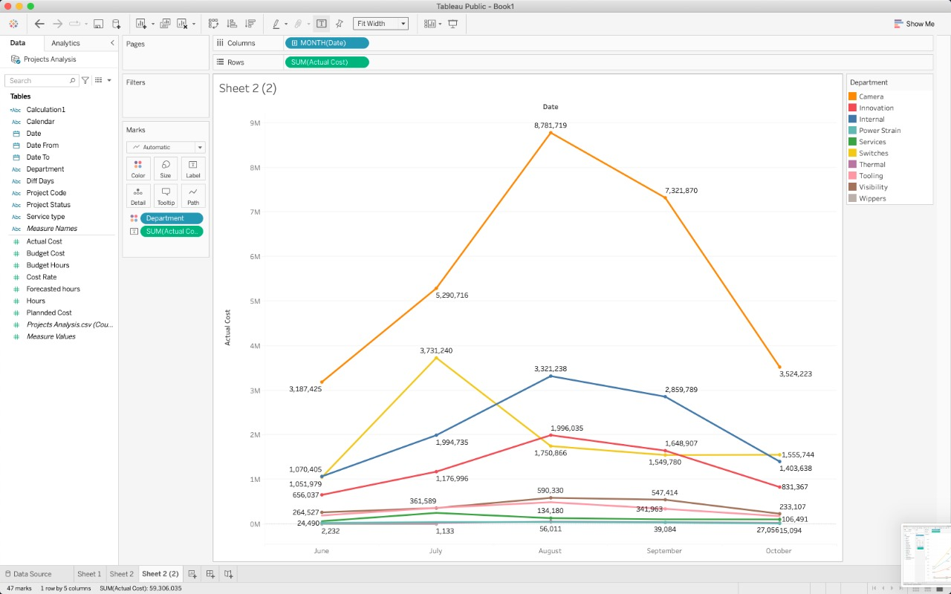

In the above figure is the actual cost over the past provided duration of months

* According to the trendlines all costs decrease by the end of August and the begining of September.
* The camera total cost increases significantly so there should be better monitoring over this product line.

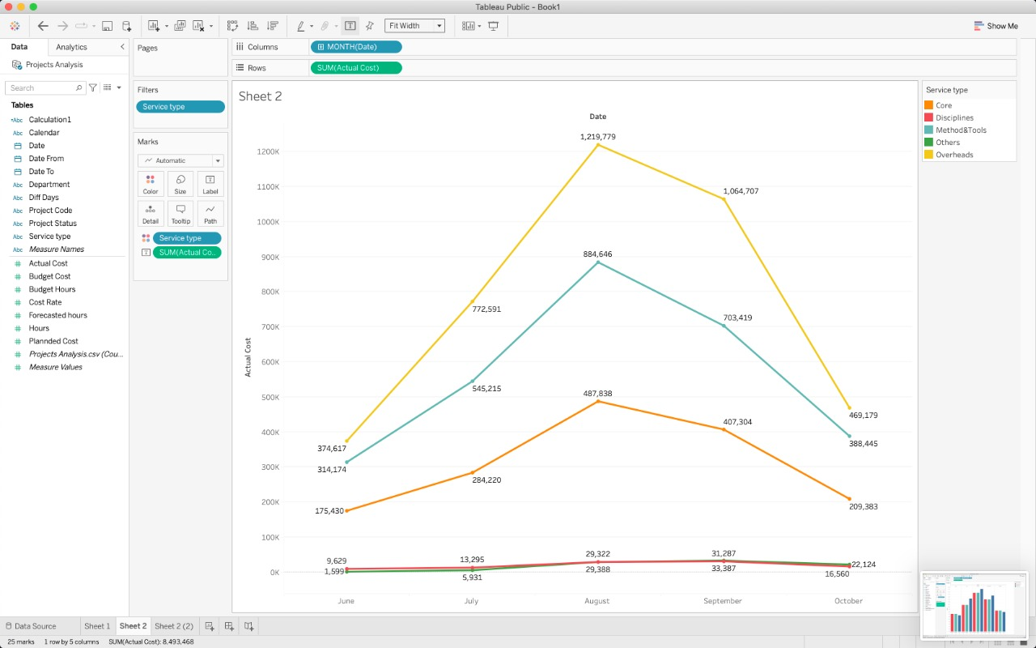

* Comparing the sum of the actual cost to the time period based on the service types
* the overheads are the most service type that has higher cost than the other service types

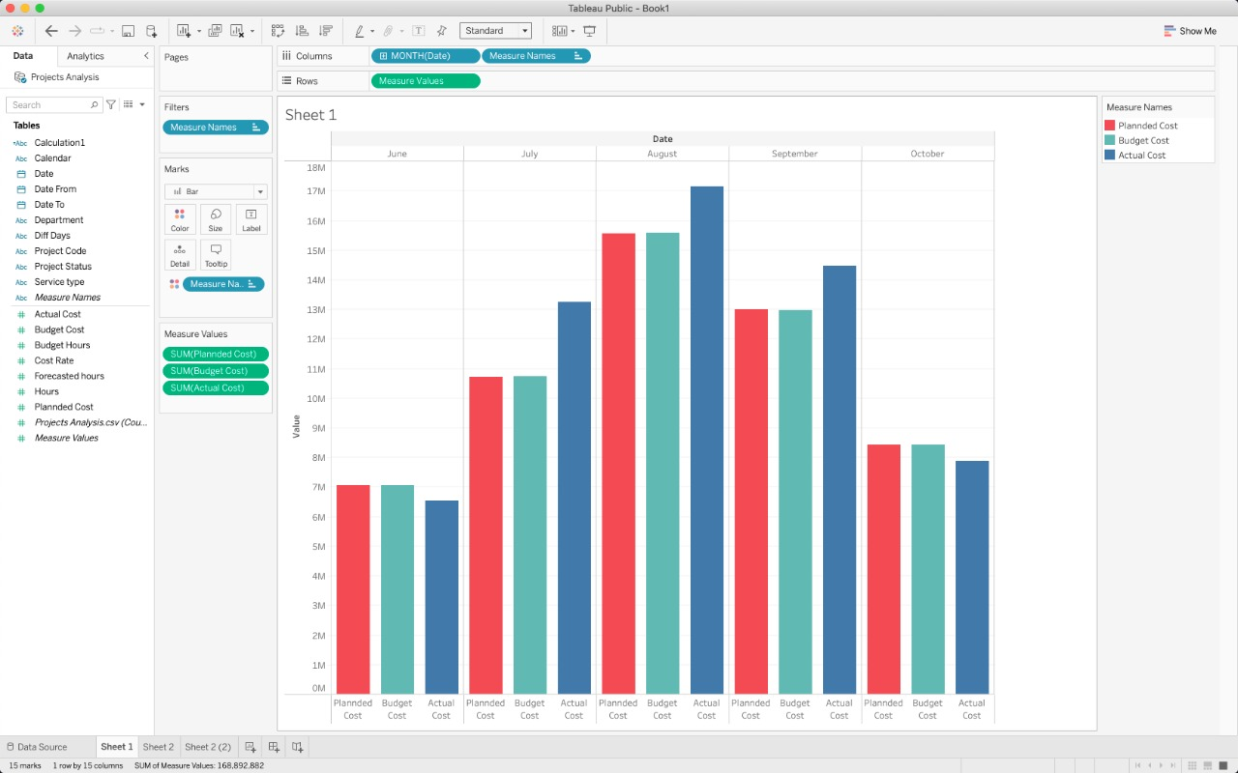

When comparing the budget and the planned cost to the actual cost, It seems that the budget cost most of the time exceeds the budget plan, There should be better calculation and forecasting for future plans